HCL EXERCISE

On Online Banking

One.jsp:

<%@ page language=*"java"* contentType=*"text/html; charset=ISO-8859-1"*

pageEncoding=*"ISO-8859-1"*%>

<%@ page import=*"java.sql.*"* %>

<%

Connection Conn=**null**;

Statement Stmt=**null**;

PreparedStatement ps=**null**;

ResultSet myRs=**null**,myRs1=**null**;

%>

<!DOCTYPE html>

<html>

<head>

<meta charset=*"ISO-8859-1"*>

<title>Insert title here</title>

</head>

<body>

<form action=*"index.jsp"* method=*"get"*>

<table border=*"1"*>

<tr>

<td>name</td>

<td>t1</td>

<td>t2</td>

<td>t3</td>

<td>t4</td

><td>t5</td>

<td>balance</td>

</tr>

<%

**try**

{

Conn=DriverManager.getConnection("jdbc:mysql://localhost:3306/sakila","student","student");

Stmt=Conn.createStatement();

System.out.println("database connection created");

myRs=Stmt.executeQuery("SELECT * from bank");

**while**(myRs.next())

{%>

<tr>

<td><%=myRs.getString("name") %></td>

<td><%=myRs.getString("t1") %></td>

<td><%=myRs.getString("t2") %></td>

<td><%=myRs.getString("t3") %></td>

<td><%=myRs.getString("t4") %></td>

<td><%=myRs.getString("t5") %></td>

<td><%=myRs.getString("balance") %></td>

</tr>

<%}

Conn.close();

ps.close();

}

**catch**(Exception e)

{

e.printStackTrace();

}

%>

</table>

<input type = *"submit"* value=*"submit"*>

</form>

</body>

</html>

OUTPUT:

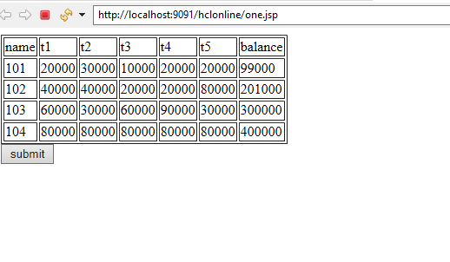

Index.jsp

<%@ page language=*"java"* contentType=*"text/html; charset=ISO-8859-1"*

pageEncoding=*"ISO-8859-1"*%>

<%@ page import=*"java.sql.*"*%>

<!DOCTYPE html PUBLIC "-//W3C//DTD HTML 4.01 Transitional//EN" "http://www.w3.org/TR/html4/loose.dtd">

<html>

<head>

<script>

**var** request;

**function** sendInfo()

{

//aler("hii");

**var** url="fundTransfer.jsp";

**if**(window.XMLHttpRequest){

request=**new** XMLHttpRequest();

}

**else** **if**(window.ActiveXObject){

request=**new** ActiveXObject("Microsoft.XMLHTTP");

}

**try**

{

request.onreadystatechange=getInfo;

request.open("GET",url,**true**);

request.send();

}

**catch**(e)

{

alert("Unable to connect to server");

}

}

**function** getInfo(){

**if**(request.readyState==4){

**var** val=request.responseText;

document.getElementById('amit').innerHTML=val;

}

}

</script>

<script type=*"text/javascript"*>

**function** vaidateData(){

**if**(document.forms[0].fromacc.value==''){

alert("Please Enter From Account No .");

//document.forms[0].fromacc.value.focus();

**return** **false** ;

}

**if**(document.forms[0].toacc.value==''){

alert("Please Enter To Account No .");

//document.forms[0].fromacc.value.focus();

**return** **false** ;

}

**if**(document.forms[0].amt.value==''){

alert("Please Enter the Amount");

//document.forms[0].fromacc.value.focus();

**return** **false** ;

}

}

</script>

<meta http-equiv=*"Content-Type"* content=*"text/html; charset=ISO-8859-1"*>

<title>Insert title here</title>

</head>

<body>

<form >

<h3 align=*"center"*>Online Banking</h3>

<table border = *"1"* align=*"center"*>

<%

Connection con =**null** ;

ResultSet rs = **null** ;

%>

<tr>

<td>Accno</td>

<td>Balance</td>

</tr>

<%

**try**{

Class.forName("com.mysql.jdbc.Driver");

con=DriverManager.getConnection(

"jdbc:mysql://localhost:3306/sakila","student","student");

//here sonoo is database name, root is username and password

Statement stmt=con.createStatement();

rs=stmt.executeQuery("select name name,sum(balance) balance from Bank group by name");

**while**(rs.next())

{

%>

<tr>

<td><%=rs.getString("name") %></td>

<td><%=rs.getString("balance") %></td>

</tr>

<%

}

}

**catch**(Exception e){

e.printStackTrace();

}

%>

</table>

<table align=*"center"*>

<tr><td></td><td><input type = *"button"* value=*"Fund Transfer"* onclick ="sendInfo();"></td></tr>

</table>

</form>

</body>

</html>

<span id=*"amit"*> </span>

Controller.jsp

<%@ page language=*"java"* contentType=*"text/html; charset=ISO-8859-1"*

pageEncoding=*"ISO-8859-1"*%>

<%@ page import=*"java.sql.*"*%>

<!DOCTYPE html PUBLIC "-//W3C//DTD HTML 4.01 Transitional//EN" "http://www.w3.org/TR/html4/loose.dtd">

<html>

<head>

<meta http-equiv=*"Content-Type"* content=*"text/html; charset=ISO-8859-1"*>

<title>Insert title here</title>

</head>

<body>

<form action=*"fundTransfer.jsp"* method=*"post"*>

<table>

<%

Connection con =**null** ;

ResultSet rs = **null** ;

String fromacc = request.getParameter("fromacc");

String toacc = request.getParameter("toacc");

String amt = request.getParameter("amt");

%>

<tr>

<td>Accno</td>

<td>Balance</td>

</tr>

<%

**try**{

Class.forName("com.mysql.jdbc.Driver");

con=DriverManager.getConnection(

"jdbc:mysql://localhost:3306/sakila","student","student");

//here sonoo is database name, root is username and password

String sql = "update Bank set balance=balance-"+Integer.parseInt(amt)+" where name = '"+fromacc+"' " ;

PreparedStatement ps=con.prepareStatement(sql) ;

ps.execute();

String sql1 = "update Bank set balance=balance+"+Integer.parseInt(amt)+" where name = '"+toacc+"'" ;

PreparedStatement ps1=con.prepareStatement(sql1) ;

ps1.execute();

}

**catch**(Exception e){

e.printStackTrace();

}

response.sendRedirect("index.jsp");

%>

</table>

</form>

</body>

</html>

Fund transfer.jsp

<%@ page language=*"java"* contentType=*"text/html; charset=ISO-8859-1"*

pageEncoding=*"ISO-8859-1"*%>

<%@ page import=*"java.sql.*"*%>

<!DOCTYPE html PUBLIC "-//W3C//DTD HTML 4.01 Transitional//EN" "http://www.w3.org/TR/html4/loose.dtd">

<html>

<head>

<meta http-equiv=*"Content-Type"* content=*"text/html; charset=ISO-8859-1"*>

<title>Insert title here</title>

</head>

<body>

<form action=*"controller.jsp"* method=*"post"* onsubmit="return vaidateData();">

<!-- <h3 align="center">Online Banking</h3> -->

<table align=*"center"*>

<%

Connection con =**null** ;

ResultSet rs = **null** ;

%>

<tr>

<td>From Acc no.</td>

<td><input type=*"text"* name=*"fromacc"*></td>

</tr>

<td>To Acc no.</td>

<td><input type=*"text"* name=*"toacc"*></td>

</tr>

<td>Enter Amount</td>

<td><input type=*"text"* name=*"amt"*></td>

</tr>

<tr>

<tr><td></td><td><input type = *"submit"* value=*"Transfer"*></td></tr>

</tr>

</table>

</form>

</body>

</html>

OUTPUTS:

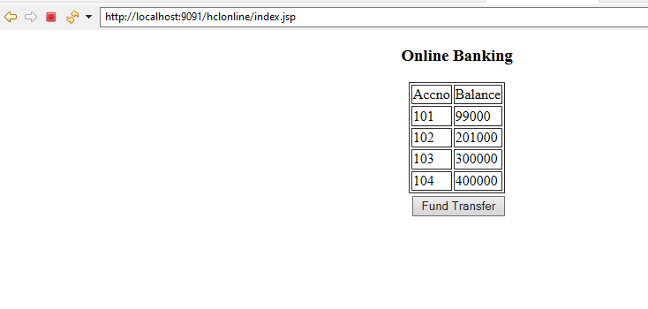

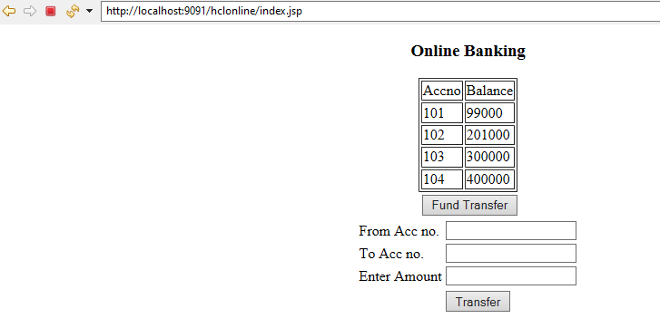

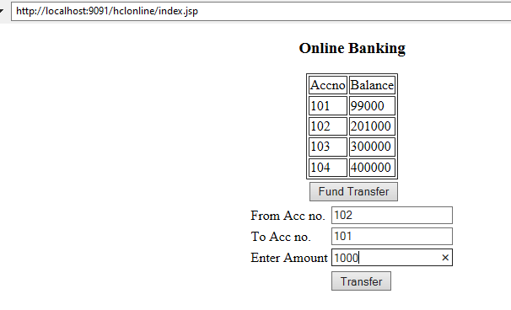

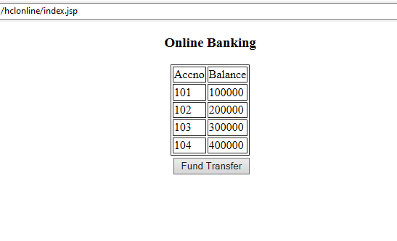

After the transaction the database can be changed as following:

